#1. Use MATLAB to visualize the spiking activity as a function of time and then as a function of the animal’s position. Include plots in your HW solutions with appropriate labels and comment on what you see.

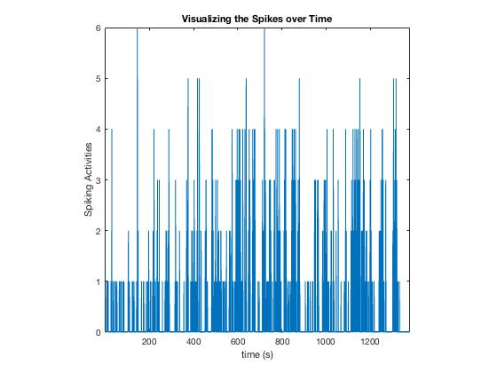

**Comments on what I observe:**

From the spikes over time, I observe that each time bin does not only contain one spike but as large as 6 spikes. The strength is different in each time bin and the spiking and the time does not have an explicit correlation.

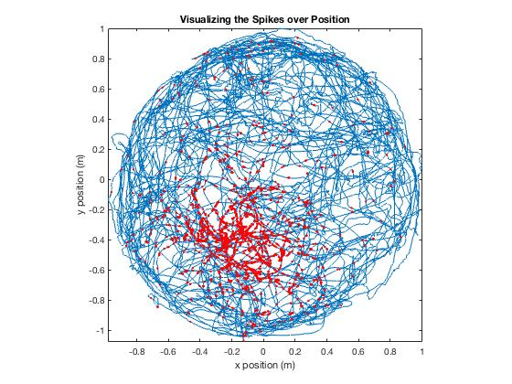

**Comments on what I observe:**

From the spikes over position, I observe that blue line represents the animal’s moving trajectories and the red dots represents spiking at a specific position. This plot shows that spiking correlates with position.

**#2. Write down Pr(dNk | …) as a Poisson distribution with mean spike count l k D .**

**Pick a set of at least two covariates (remember, this can include any function of the variables above) and write an equation that linearly relates log( lambda_k ) to your covariates. Visualize the model by plotting the predicted ( lambda_k ) as a function of two of your covariates.**

$$\operatorname{Pr}\left(dNk | …\right)=\frac{e^{-\left(λ_{k}∆\right)}}{dNk!}{\left(λ_{k}∆\right)}^{dNk}$$

$$\log\left(λ_{k}\right)=β_{0}+β_{1}x^{k}+β_{2}y^{k}$$

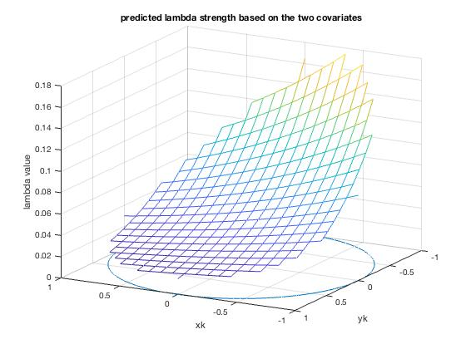

Plot the above figure using ‘glm_part1_Hui.m’

# 3.

$$L\left(θ\right)= \prod_{k=1}^{K}{exp⁡\{dNk\left(β_{0}+β_{1}x^{k}+β_{2}y^{k}\right)-\log\left(dNk!\right)-exp⁡(β_{0}+β_{1}x^{k}+β_{2}y^{k})\}}$$

#4.

By running MATLAB code ‘glm_part1_Hui.m’, we find that the parameters for this simple set of covariates are:

$$β_{0}=-3.0153; β_{1}=-0.4889; β_{2}=-1.2117$$

In the Gaussian-shaped hill activities, By running MATLAB code ‘glm_part1_Hui_Gaussian.m’, we find that the parameters for this simple set of covariates are:

$$β_{0}=-1.2760; β_{1}=-5.8464; β_{2}=-2.3361$$

The modification made here include

[b,dev,stats] = glmfit([xN yN],spikes_binned,'poisson')🡪

[b,dev,stats] = glmfit([xN.^2 yN.^2],spikes_binned,'Poisson');

and

lambda = exp(b(1) + b(2)*x_new + b(3)*y_new)🡪

lambda = exp(b(1) + b(2)*x_new.^2 + b(3)*y_new.^2);

Visualization from #5 shows that the covariate Xk changes the lambda value on the xk axis and the covariate yk changes the lambda value on the yk axis. Overall, lambda is dependent on both of the covariates

#5.

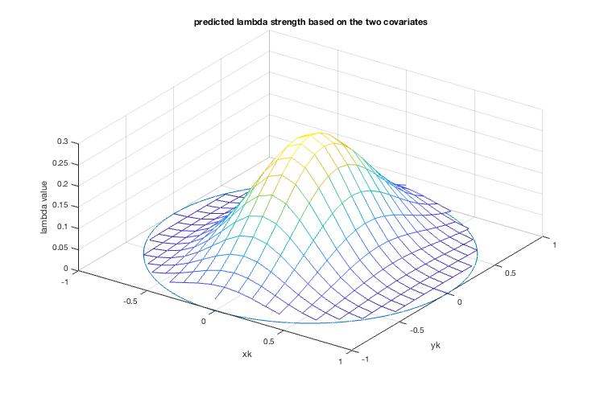

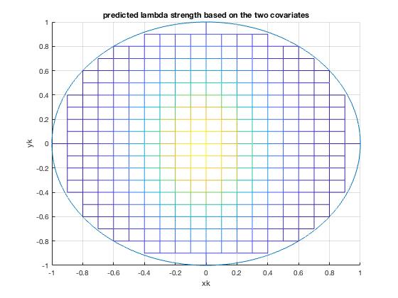

Although it doesn’t match up completely, the spiking occurs both in the central region in the plots.

#6. 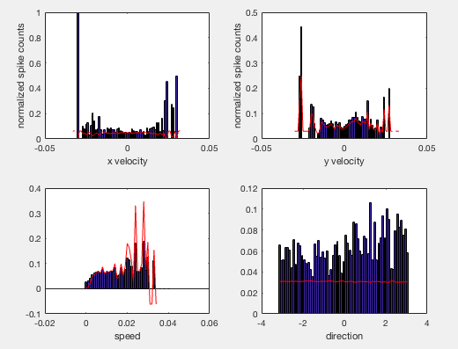

plotted with ‘glm_2_Hui.m’

Among the 4 histogram, I can only fit the third plot well with the parameterized estimation and the histogram. The relationship between the speed and the spiking seems to be sqrt(covariate) ~spiking

Left top: Histogram of spiking to x-velocity: The best fit I can find between the x velocity and the spiking has a relationship: exp(covariate)~spiking. However, it doesn’t fit very well.

Right top: Histogram of spiking to y-velocity: The best fit I can find between the y velocity and the spiking has a relationship: sqrt(covariate) ~spiking

Left bottom: Histogram of spiking to movement speed. The best fit I can find between the speed and the spiking has a relationship: sqrt(covariate) ~spiking

Right bottom: Histogram of spiking to movement direction. The best fit I can find between the movement direction and the spiking has a relationship: sqrt(covariate) ~spiking

Overall, the histograms suggest that the relationship between spiking and velocity is sqrt(velocity) ~spiking